F03B-25 Cutting Head User Manual

（1） Summarize 1
（2）Parameter 2
（3） Product Features 3
3-1 Modularly Combined 3
3-2 Adjust the precision 3
3-3 Easy operation, User-friendly 3
（4）Installation 4
4-1 Installation Sketch 4
4-2 Tube Connection 4
4-3 Optical fiber put in and take out method 5
（5）Adjustment of the focus 5
5-1 Focus instruction 5
5-2 Focus lens adjusting method: 6
5-3 Adjustment of Collimating Mirror 6
（6）Maintenance of focus lens 7
6-2 cleaning of focus lens 8
6-3 Installation of focus lens case 8
（7）Maintenance of the Protective mirror 8
7-1 Taking out of the protective mirror case 8
7-2 Cleaning of protective mirror 9
7-3 Installation of protective mirror case 9
（8）Replacement of quick-wear part 9
（9） User attention 9

Summarize
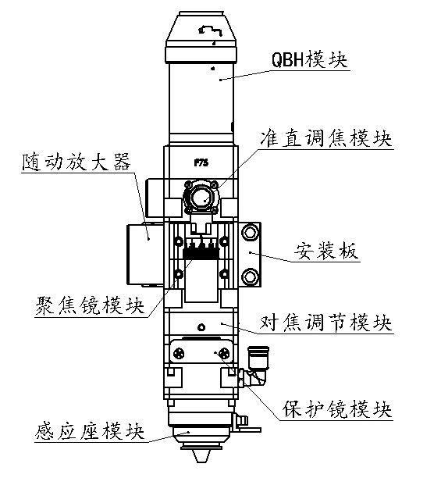
F03B-25-120 is the latest fiber laser cutting head. Widely used by our company laser machines with features: attractive appearance, novel structure, easy operation, accurate focus, reasonable airflow combination, etc.
QBH module
Collimating lens module
mounting plate
Focus adjustment module
focus lens module
auto-following amplifier
Prior applicable for low&medium power solid and gas laser cutting machines.
Cutting head is combined with:

QBH module, Collimating lens module, mounting plate, auto-following amplifier, focus lens module, Focus adjustment module, protective mirror module, sensor module.
protective mirror
sensor module

（2）Parameter
Laser power | ≤1000W
Fiber plug type | QBH, QCS etc.
Collimating mirror  diameter and focal distance | φ25mm F 75mm/100mm/120mm
Focus lens diameter and focal distance | φ25.4mm F 80mm/100mm/120mm
Protective mirror diameter | φ22.3mm
Max length | 336.4mm
Cutting head external diameter | 50mm×50mm
Weight | 1.94Kg
Water pressure request | 0.5MPa
Air pressure request | ≤2.5MPa
Remark: please contact us if you have special request on focal distance and installation dimension or other parameters.

Product Features

3-1 Modularly Combined
3-1-1 Applicable for kinds of fiber laser source connections
For example:QBH plug, and all kinds of QCS connections with different diameter
3-1-2 Applicable for kinds of Collimating lens combination with different focal distance
3-1-3 Applicable for kinds of focus lens combination with different focal distance

3-2 Adjust the precision
3-2-1 Adjustment of focus lens precision: Z axis can be controlled to 0.005mm
Screw type Precision focusing mechanism has high self-locking performance, can ensure the stability of the mirrors during working.
3-2-2 It has focusing mechanism for the collimating lens, applicable for different kinds of mirrors focal distance.

3-3 Easy operation, User-friendly
3-3-1 There are scales for the focusing mechanism of focus lens and collimating lens, easy for observation and operation
3-3-2 Protective mirror is fixed in the structure as button drawer, easy for exchange 3-3-3 Standard spanner with machine which can be used to change mirror structure

（4）Installation

4-1 Installation Sketch
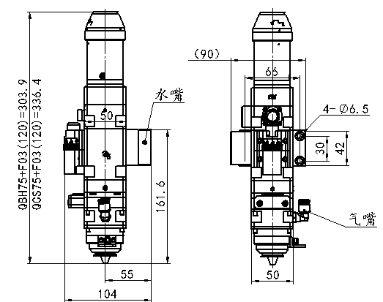
air faucet

Water faucet

4-2 Tube Connection
4-2-1 Install water and air faucet according to sketch
4-2-2 Requested condition of water and air
Water type | purified water
interface specification | water pipe inner and outer diameter φ4mm/φ6mm
Water flow | 2.0L/min(no need water chilling touch temperature under 45°)
Water Temperature | 15°~30°
Blow Compressed | 1~2.5MP（changed according to material thickness）
Air medium | Air or nitrogen without water &oil

4-3 Optical fiber put in and take out method
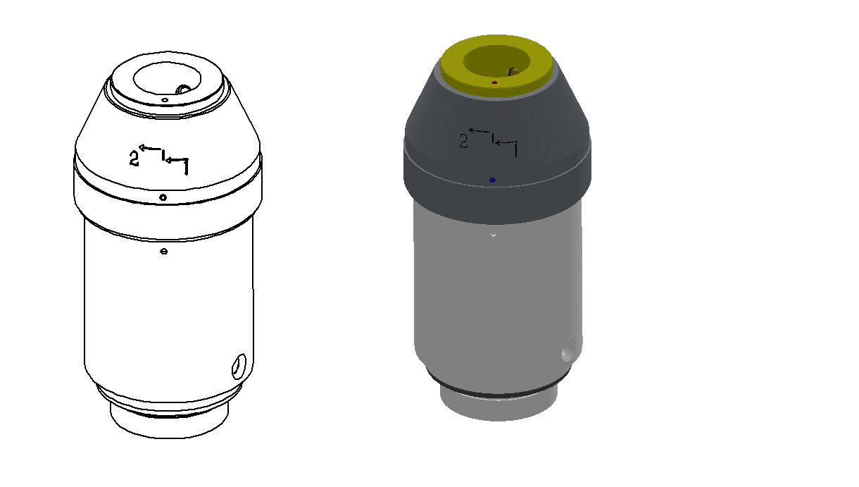
4-3-1 QBH plug put in sequence
Take off the dust cover on the chuck
Aligning the red point from plug to the QBH chuck, then insert into the bottom
According to the mark on QBH chuck，turn left the screw nut(45°), then pull up 1.25mm, then turn left (30°), finally, finish the Fixed lock program.
4-3-2 QBH plug take out sequence
QBH plug pull out sequence is contrary to put in. Turn right (30°), push off 1.25mm, turn right(45°), finally, can take the plug out of the QBH chuck.
Be attention of the environment during pull out process, make sure no dust inside.

4-3-2 QCS plug put in and take out method
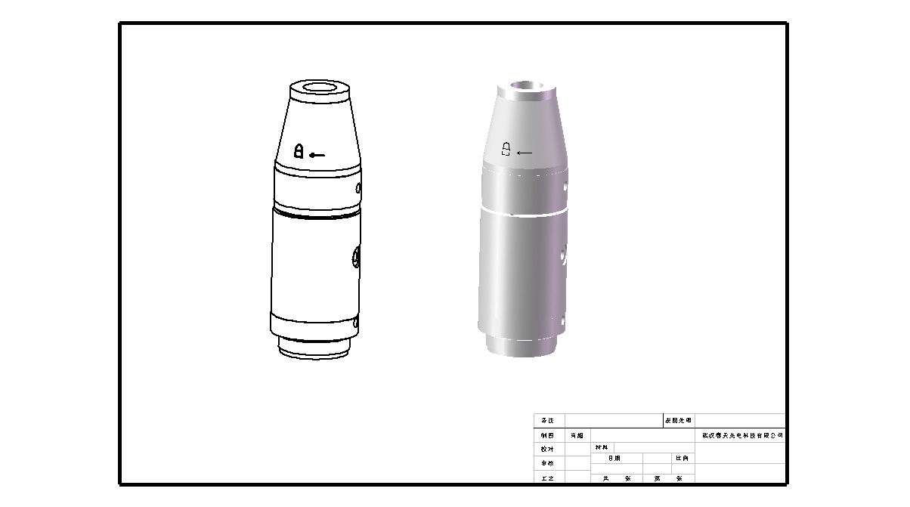
This product can also applied for QCS fiber plug. The operation sequence as below:
Take off the dust cover on the chuck
Anti-clockwise direction loosen the nut of chuck
Put the QCS plug inside and tightening the nut clockwise
Sequences are in verse for putting in and taking out
Cover up the dust cap after taking QCS plug out, To prevent dust intrusion.

（5）Adjustment of the focus

5-1 Focus instruction
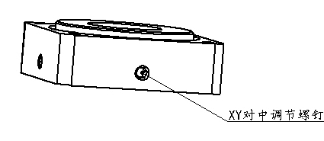
There is a focus centring module on the top of protective mirror. And 4 centring adjust screw all around the module.
Advantages: Rigid positioning, focus is stable after locked the centring adjust screw.
XY centring adjust screw
Centring method: if need move to the left, loosen the screw left side and then tighten the screw right side. Vise verse.
Finish the centring work, fix these two screws and then locked them.
The method are the same if want to move the module front and back.

5-2 Focus lens adjusting method:
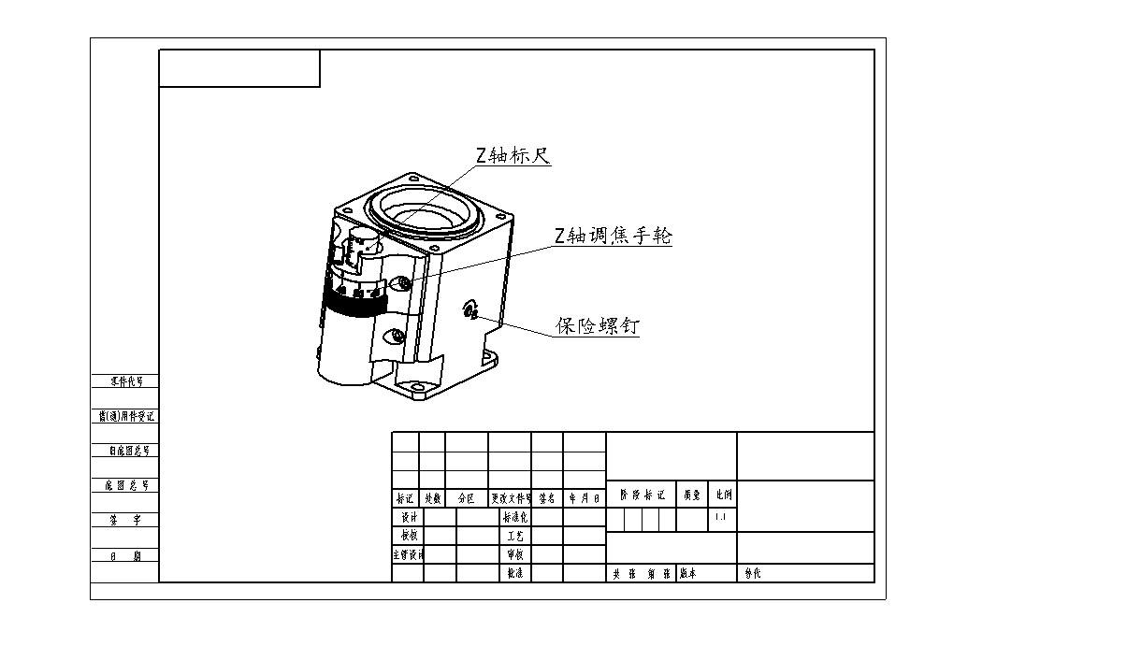
Focus lens adjusting organization realize focus on Z axis with high-precision screw which have perfect self-locking and fine focusing performance.
Z axis scaleplate
Focus adjust hand wheel
Focusing module has adjusting hand wheel with 50 equal scale, every scale, focus lens will go up or down 0.02mm, every round, the lengthways pole will go up or down 1mm. The lens can move vertical 10mm. There are scales 0,+5,-5,0 which near the nozzle, +5 means the focus retract into the nozzle the most. -5 means out the most. There is an insurance screw on the side of focusing module. You can use it to adjust the mechanical clearance if the cutting head keep long-term work.
Insurance screw

5-3 Adjustment of Collimating Mirror
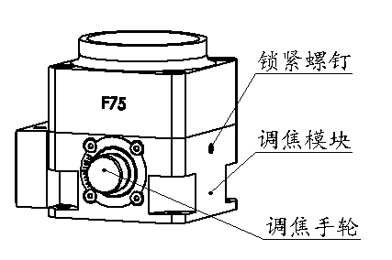
The focal distance are different from different manufactures. There is a focus adjusting module under Collimating lens seat.
Lock screw
Focus adjusting module
There are total 10 scales on the focus adjusting wheel: 0-center of mirror,+5-top, -5-bottom. If need to adjust light beam, unlock screw, adjust, then lock.
Focus adjusting wheel

Remark: location of mirror are adjusted well before machine exit warehouse. Users no need to adjust more the time.

（6）Maintenance of focus lens
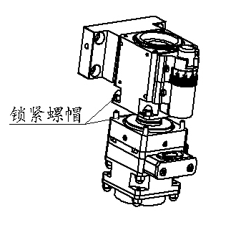
Focus lens under the adjusting module, need to do maintenance periodically. It’s better 1-2 months per time under clean environment.
6-1 Taking out of the focus lens case
Lock screw
Unscrew four screws, take off module in bottom
Take out the focus lens case with Wire ring spanner. Attention: can only take it our if spanner bayonet align to the bayonet on mirror case.
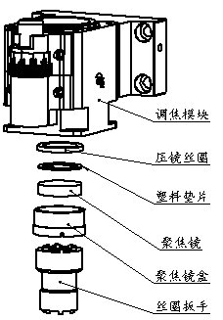
After taking out the case, use wire ring spanner screw wire ring and take out the plastic spacer and focus lens.
Focus lens adjusting module
Wire ring
Plastic spacer
Focus lens
Focus lens case
Wire ring spanner

6-2 cleaning of focus lens
6-2-1 tools: dust proof glove, Long fiber cotton wool, isopropyl alcohol, rubber blower.
6-2-2 cleaning method:
Take on glove, hold the mirror, use alcoholled cotton wool clean the mirror.
Cleaning method: from down to up, or from left to right, clean the mirror lightly unidirection. Please do not clean the mirror back and force which can lead to secondary pollution. Need to blow the surface of mirror after cleaning.

6-3 Installation of focus lens case
The sequence for taking out and put inside of the lens case are opposite. Put focus lens, plastic spacer, wire ring inside of the focus lens case, then fix wire ring use spanner, finally put the case into focal adjusting module.

（7）Maintenance of the Protective mirror
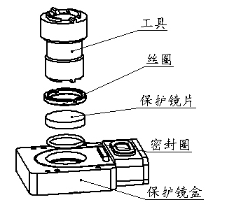
Protective mirror is under the centring module, easy polluted, should be cleaned every week.
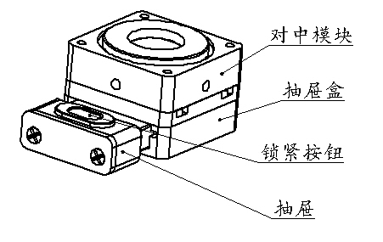
Centring module
Drawer
Lock button
Drawer
Tool
Wire ring
Protective mirror
seal ring
Protective mirror case

7-1 Taking out of the protective mirror case
Hole the handle of the protective mirror case, pull out slightly, seal the drawer with gummed paper to proof dust inside.

7-2 Cleaning of protective mirror
Screw out the wire ring with spanner, take out the mirror, and clean it with the same method of focus lens cleaning.

7-3 Installation of protective mirror case
Protective mirror is plane mirror, can be put inside of the case directly. Sequence is opposite to the way taking out. Press the handle on the drawer and locked it. Then put inside, finish.

（8）Replacement of quick-wear part
Sensor seat
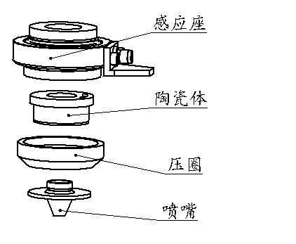
8-1 The nozzle under the cutting head is easy damaged. User can contra-rotate the nozzle easily. After replace the new nozzle, capacitance calibration work is needed.
Ceramic body
8-2 If the ceramic body is broken, need to take off the nozzle pressure ring, take it out, and replace a new one. Attention, need to align the location hole on the sensor seat to the gauge pile, then tightening the pressure ring. Otherwise, the sensor seat can be damaged.
Pressure ring
Nozzle
8-3 If need to replace up mentioned broken quick-wear parts, please contact us.

（9） User attention
9-1 This product has been apply for a patent, please contact our technical engineer if need more technical information.
9-2 Installation, maintenance and other operation work need to be done by engineering technicians. It include such works about focus lens, protective mirror and nozzle. Please do not dismounting other parts without our permission. Otherwise, it will affect the precision of products.

